# COMP3500: Project 4-2 Introduction to System Calls

**Exercise 1:** Read the command-line parser source code and answer the following three questions.

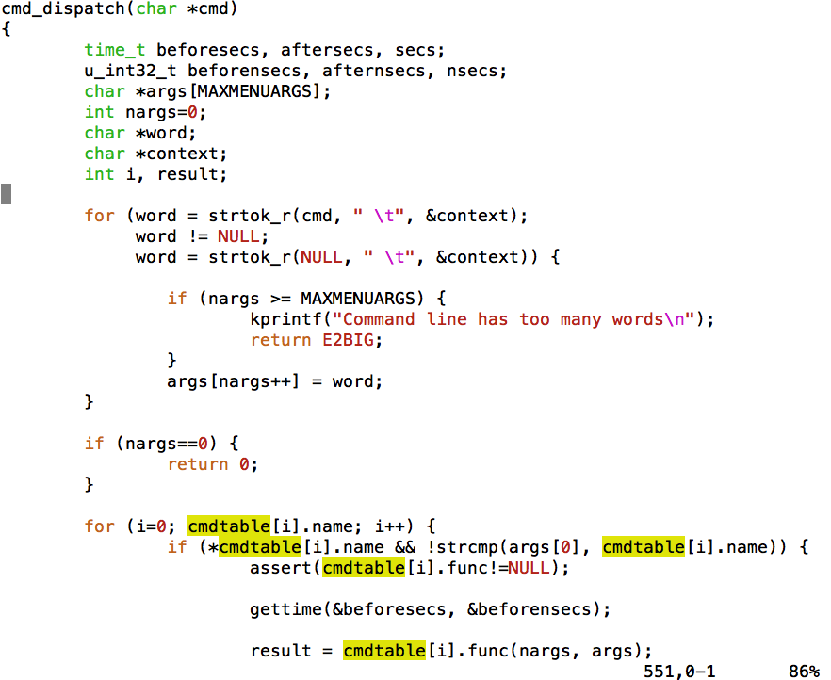

(1.1) What does word represent in this command-line parser?

(1.2) **(Plickers)** Which variable holds a command?

A. cmdtable[0] B. args[1] C. args[0] D. cmdtable[i]

(1.3) **(Plickers)** Which line invokes the command function?

A. word = strtok_r(NULL, “ \t”, &context);

B. args[nargs++] = word;

C. gettime(&beforesecs, &beforensecs);

D. result = cmdtable[i].func(nargs, args);

**Exercise 2:** (1.1) What is the first thing to do when an OS runs a program? (Hint: where is the program stored?)

(2.2) Can you figure out how the data are flowed from one module into another?

**Exercise 3** Read the source code of the system-call handler and answer the following questions.

(3.1) Why curspl == 0?

(3.2) What is the tf->tf_v0 variable?

(3.3) Where is the tf->tf_a0 variable coming from?

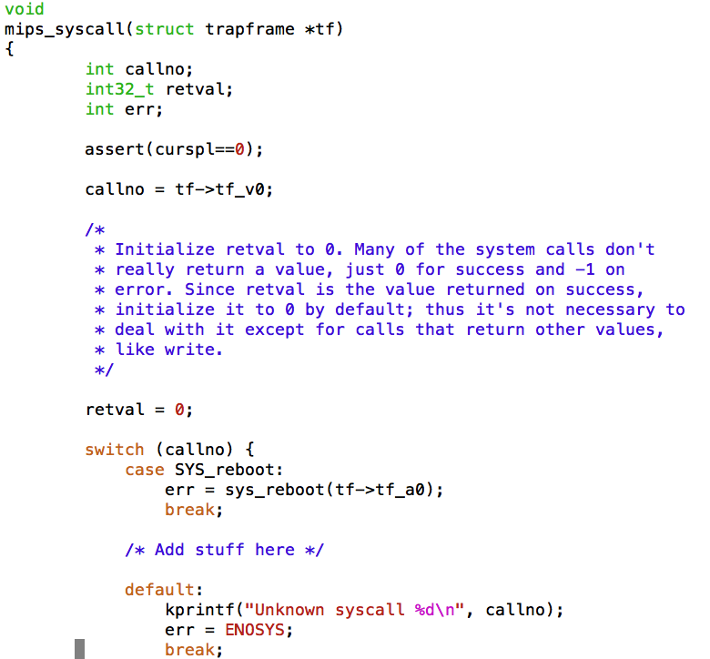

**Exercise 4 (Plickers):** How does the main() function return a value back to controller crt0.s?



A. return B. move s0, v0 C. jal main D. jal exit

**Exercise 5 (Plickers):** Is this program an application or a part of the kernel?

A. Application B. Part of Kernel

